Annual General Meeting

Sunday 19 February 2023

Table of Contents
Membership Feb 2023 2
Minutes of previous meeting 3
Pastoral Search Team Report 5
Church Secretary’s Report 7
Treasurers Report 9
Trustees Report 12
Stewards Report 13
Children’s Ministries 14
Men`s Breakfast Report 15
Interim Pastors Report 16
Health & Safety Information 18

Membership Feb 2023

Appleby Josephine
Appleby Michael
Brandon Bruce
Brandon Hazel
Brooks Ann
Capel Peter
Carr Ebun
Carr Herbert
Chapman Eileen
Christiansen Craig
Christiansen Rochelle
Cooper Sarah
Dowty Bob
Dowty Carole
Dowty Richard
Endean Sarah
Finch Marian
Fry Norman
Fry Wendy
Goodman Catherine
Gullotti Daniella
Hodder David
James Ann
Lees Kate
Maina Monica
Males Charmian
Mallaby Stuart
Millar Jackie
Milligan Denise
Milligan Paul
Morse Ann
Munday Hayley
Murphy Carol
Murray Moira
Okewoye Adeola
Packham Janet
Schofield Naomi
Seddon Paula
Smith Norma
Stanbridge Ruth
Sweeting Brian
Sweeting Lynn
Thirkell David
Thompson Joan
Toth Judit
Tranter Andrew
Valentine Joanne
Walker Betty
Wells Thomas
Welling Danielle
Wilson Fiona
Wilson Isobel
Wyatt Mary

Minutes of previous meeting

Annual General Meeting
Woodside Community Church of the Nazarene
27th February 2022

Present: Rev Tommy Goodwin MBE(Chair), Naomi Schofield, Bob Dowty, Rochelle Christiansen, Carol Dowty, Ann Brooks, Bruce Brandon, Hazel Brandon, Herbert Carr,
Ebun Carr, Sarah Endean, Charmian Males, Betty Walker, Joan Thompson, Ann Morse,
Jo Appleby, Michael Appleby, Janet Packham, Catherine Goodman, Kate Lees,
Craig Christiansen, Andrew Tranter (Secretary).

Apologies for Absence: David & Jean Thirkell, Spike & Denise Milligan, Paula Seddon,
Chris Lynwode, Jackie Miller, Norma Smith, Moira Murray, Stuart Mallaby.

Reflection: Pastor Tommy reminded the fellowship that the compendium of reports is the storey of the church over the past year; our sacrifices, our working together, our reaching out to each other and to the community. Thank you to all who prepared reports representing the ministries and responsibilities of the church.

Nominating Committee: There was no nominating committee appointed this year as no new nominations for the Church Board were received.

Voting: Pastor Tommy suggested that voting be registered by `hand` this was proposed by Bob Dowty, Seconded by Catherine Goodman. All in Favour. Agreed

Adoption of the AGM Reports: Adoption of the Reports proposed by Charmian Males,
Seconded by Jo Appleby. All in Favour.

Treasurers Report: Ann Brooks, two questions; was there a long term plan? Yes, a draft report has been drawn up by Chief Trustee Craig Christiansen in consultation with the treasurer and distributed to Board Members for action by the new CB in the new Church Year. Gift Aid, yes, and more encouraged to join. Accounts to be Independently Audited.
Standing for the Church Board;
Andrew Tranter Church Secretary.
Ann Brooks Church Treasurer.
Carol Dowty Assistant Treasurer.
Craig Christiansen Chief Trustee.
Bruce Brandon Assistant Trustee.
Moira Murray Chief Steward.
Josephine Appleby Steward.
Paula Seddon Children`s Ministries.
Block Vote by Show of Hands, Unanimous.

Delegates to Attend the District Assembly 11-12 march 2022.
Three delegates are required to represent the church at the District Assembly at St John`s
Vicarage Drive Dukinfield, SK16 5HZ Manchester.
Pastor asked members if they were available to attend, Kate Lees, Carol Dowty and Andrew Tranter are available; Charmian Males agreed to be the Alternate.
Moved for adoption by Ann Morse, Seconded by Betty Walker. All in Favour.

Pastor Tommy Goodwin closed the meeting with prayer.

A Tranter Secretary. 7 March 2022

Pastoral Search Team Report
I write to you with an overview of the activities and work of the pastoral search team over the past year.
Since being formed, in summer of last year, the pastoral search team has worked and endeavoured to find the pastor for our flock here at Woodside. We set out by identifying the qualities that were important for a leader for our church, such as having a heart and passion for the community and being an inspiring communicator.
As part of the work we undertook, we pulled together an advertisement and community profile pack for information purposes assisting any potential candidates, to learn more about us, and in turn we hoped would help to draw in the right leader. These criteria and advertisement were in part formulated from the feedback offered through Tommy's series of 'looking' sermons, where the congregation participated in completing sticky notes in accordance with the theme of the service.
We have been further supported by Tommy, as interim minister, who has shared his experience with us, impartially and objectively mentoring us in the process of finding a pastor.
Together we worked prayerfully and with discernment, taking into account the importance of the task at hand. We discussed and debated potential candidates, some who had visited over the past year, others who had applied responding to the advert. Throughout, we asked the Lord for guidance and direction in this important decision-making process. We remained focused on the qualities and attributes we were looking for and we relied on the Lord to lead us in our search and the due diligence process.
As we have carried out our search, we trusted and continue to trust that this prayerful process will lead us to the candidate and shepherd for Woodside Community Church of the Nazarene. We remain confident that the criteria we have set out will help us identify and call the right person, and we looked forward to the day when the flock at Woodside Community Church of the Nazarene would have its own pastor/leader.
We continue to pray regularly with the church board, for guidance and ask for the Lord’s blessing in this important endeavour. We thank Him for every person who we have had the opportunity to hear from, and we maintain hope and faith in the process.
We remain patient and we trust wholeheartedly that the Lord will answer our prayers and bless us with a new pastor that will bring us closer to Him and help the church grow.
We are working for and on behalf of the congregation, so do keep speaking with us and offering us invaluable thoughts, ideas, suggestions and feedback, which we can use to help us in the decision-making process.
The search continues.... we ask that you continue to keep the pastoral search team in your thoughts and prayers. Once it is known who we believe is most suitable and identify as a good fit, a recommendation will be made to the church board, and a formal announcement from them will be made accordingly to the congregation giving you the opportunity to prayerfully consider extending a call.

Daniel Sweeting, Coordinator, The Pastoral Search Team

Church Secretary’s Report

Pastor, Members` Friends.

The Apostle Paul encouraged the Philippian church with these words, ….. “make my joy complete by being like-minded, having the same love, being one in spirit and purpose”.
Reflecting on the past year, when we set out on a new journey of ministry in the community and a new interim Pastor/shepherd, Rev Tommy Goodwin, we can look back with thankful hearts and say amen to the words of the hymn by Fanny J Crosby, `All the way my Saviour leads me, what have I to ask beside? Can I doubt His faithful mercies? Who through life has been my guide, Heavenly peace, divinest comfort Ere by faith in Him to dwell. For I know whate`er befall me, Jesus doeth all things well.

We recognised at the start of the new church year that as a fellowship, due to Covid and the loss of our shepherd there was a need to draw the congregation together, to prepare our hearts and minds for the task of rebuilding the “walls” of the church into our community. One very bright light in our community activities is the Little Stars, headed up by Paula Seddon and her team. Lots of `tots` and mums, dads, grandads and grandma’s attend the activity with plenty of scope to engage further with them.

Pastor Tommy has had a big impact on the church family; his inclusive ability to draw all age groups together has promoted unity and a bond of love that is evident in the fellowship. Many in the congregation take part in the worship which is `live streamed` and is testament to a growing awareness that God is at work. We are seeing new families and individuals worshiping with us week by week, a great encouragement in building “up the temple of the Lord”.

A highlight of our weekly programme is the Wednesday Night Zoom Prayer Meeting. We are regularly joined by brothers and sisters from North of the Boarder in Scotland, we get up to date weather forecasts’
from Loch Lomond and Irvin near Glasgow! We have a regular participant from Northampton who joins us with his `pet Cookoo` it normally joins in when Spike is praying, can`t say “Amen” yet. On a serious note
Jo Appleby and Ebun who lead these sessions, we are grateful for their commitment to this vital ministry. We have come to depend on supporting each other and the wider fellowship in prayer and have witnessed many gracious answers to our prayers.
A notable answer to our prayers was for young Ryan, a thirteen year old boy from our Sunday School who was diagnosed with Leukaemia and had to be treated in the University Collage Hospital in London. His Mum Claire and little sister Chloe were constantly on our hearts during his illness. Mercifully God has answered our prayers and Ryan is now in remission.

The prayer time has also helped us as a fellowship support those in our fellowship who have lost loved ones, `promoted to Glory`, it is a difficult time for all, good to put our arms around them physically and commend them to `the God` of all comfort.
We continue to remember Rev David Thirkell and the family at the home calling of Jean his dear wife and the mother of Paula and Grandmother of Katie.

Pastor Tommy initiated a `pastoral search` team to focus on identifying a suitable `shepherd` to lead the church into the future. We have had several pastor`s visit us not necessarily with a view to a call to the ministry at Woodside, but to give us an understanding and appreciation of the responsibility in filling this important vacancy.
Pastor Tommy has been instrumental in introducing several Pastors from both the North and South Districts to us and we are confident that God will make known to us through His Holy Spirit the Shepherd He has appointed to lead us for such a time as this.

I thank the Church Board for their support to Pastor Tommy and the fellowship in general. Special thanks to Ann and Carol for looking after the church finances. We are excited about the future, recognising that it is “together” in unity that we will bring glory and honour to Almighty God as we seek to serve Him and our community. To God be the Glory.

Thank you to all who serve in the background, Naomi of the keyboard; the tech team on the balcony, Phillis and her floral arrangements, those who clean up and man/woman the kitchen, stewards, hope I haven’t missed anyone!

There is joy in serving Jesus, and His people.

Respectfully submitted
Andrew Tranter Secretary.

Treasurers Report
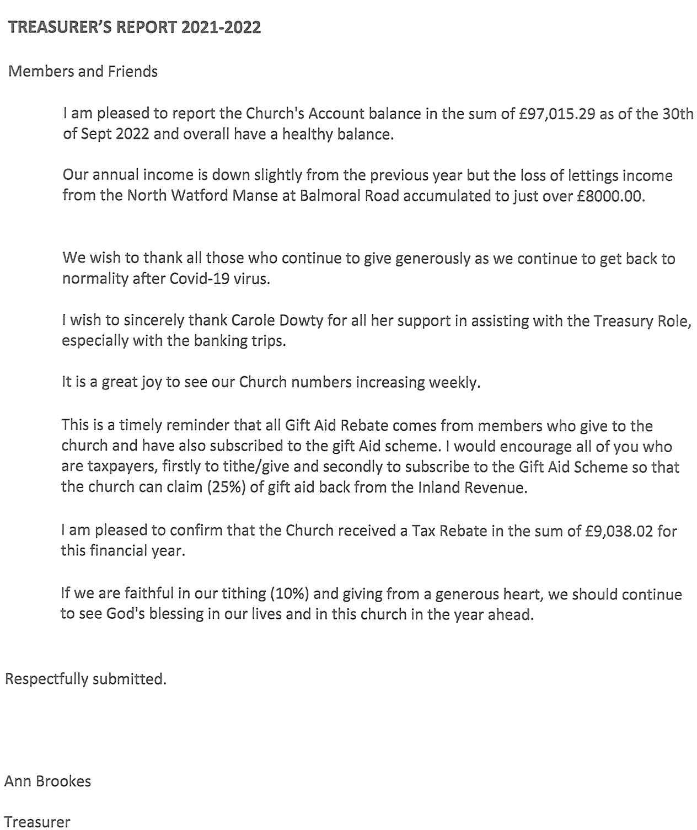

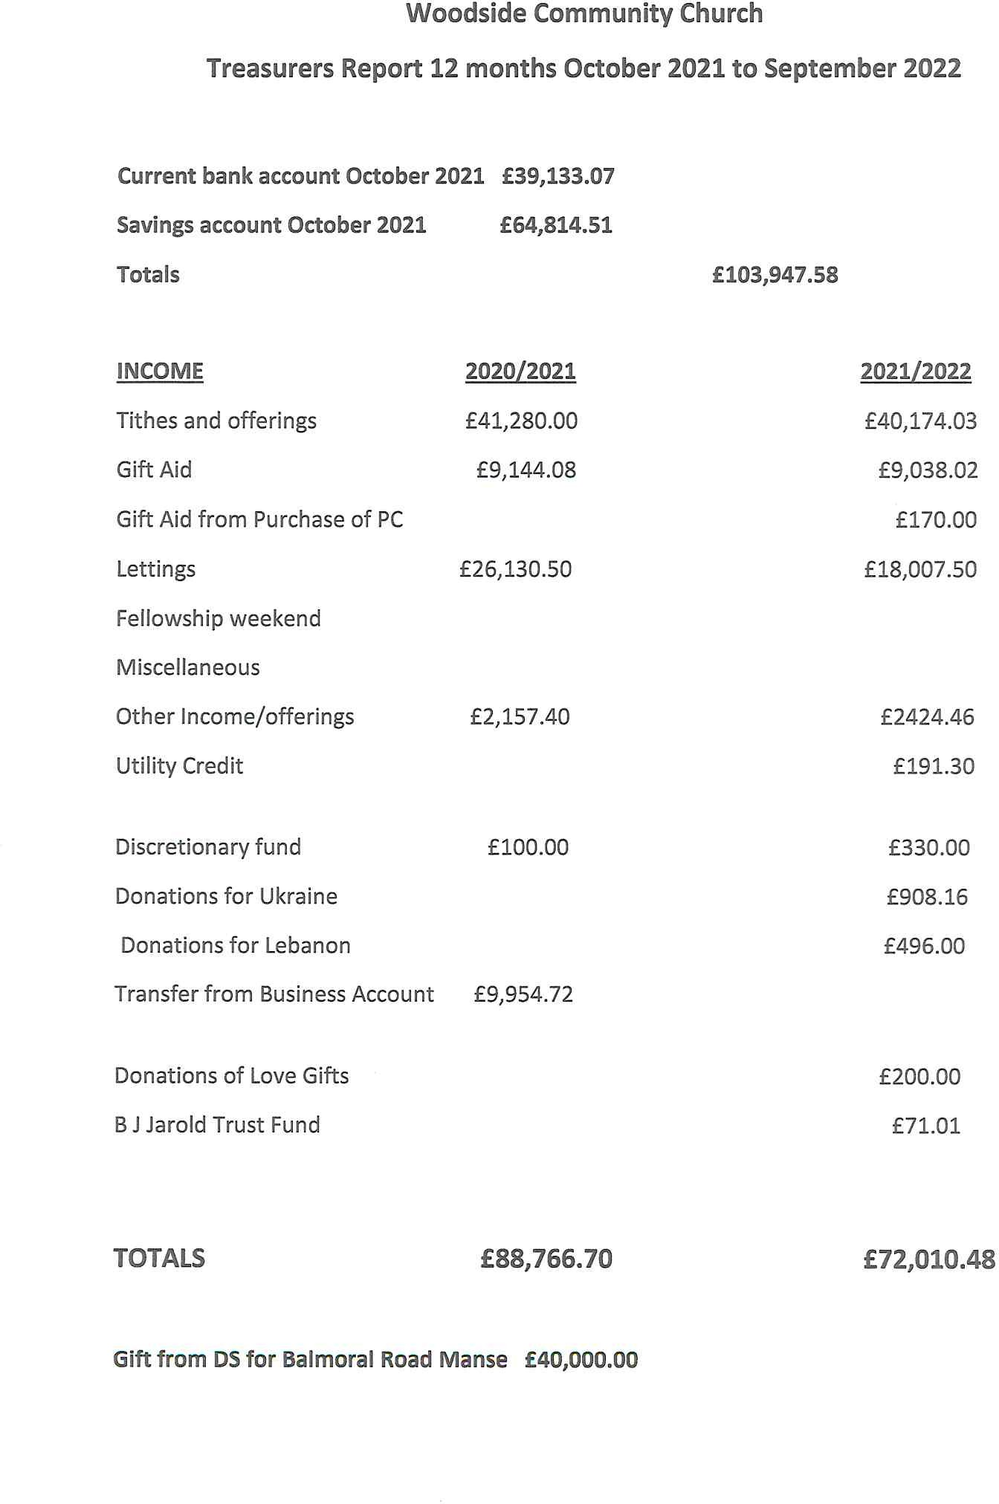

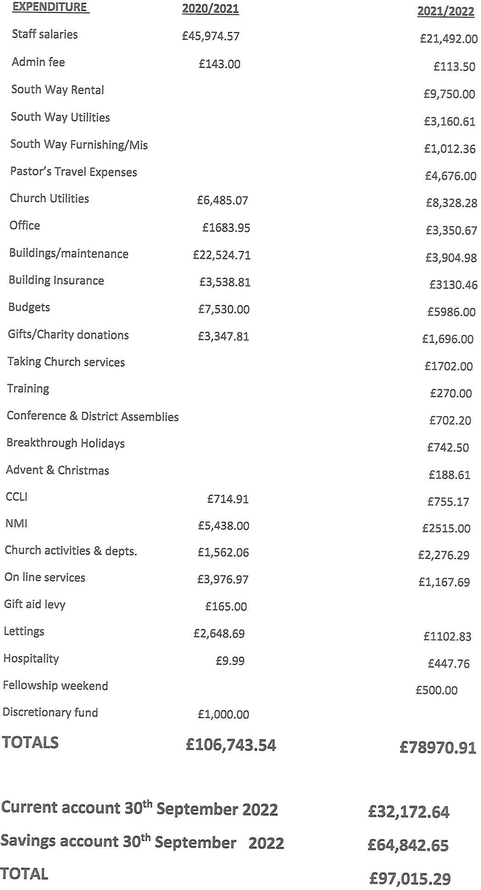

Trustees Report
Head Trustee Report 2023
Pastor, Members, Friends
In past reports I kept saying “when we get back to normal”. Well I think we are now back in a normal state (whatever that is?) as we have even had a workday.
This past year we have not had to carry out any major repairs to the Church building. External trades were brought in for boiler maintenance, fire extinguisher certificates, and alarm maintenance. Unfortunately, our trusted electrician Gavin passed away so we extend our thoughts and prayers to Bruce, Hazel and family.
We have retained one external group that rent the Hall on a Thursday and Friday evening which provides some extra income. We are not advertising ad-hoc bookings as these don’t prove worthwhile and we are not having to fund a caretaker salary.
We have received another full year of rent from the manse and are thankful for good tenants. All the certificates required for a rental property have been renewed. Repairs were carried to the boiler and in the kitchen we had the sink cabinet and plumbing replaced. It looks as though this has resolved a long-standing damp issue. Looking ahead to the near future we need to prepare the manse for our new pastor so need to assess the extent of work needed to bring the house up to the best possible standard.
The AV team have done a great job in supporting the services, the new PC has work well and was a needed investment. Onsite worship is our preference, but we will continue an online presence as views are typically around 60, highest being 143. If you haven’t yet, please subscribe to the YouTube channel as this will activate extra features.
Thankyou Bruce for continuing to oversee a lot of detail in many areas such as utilities contracts, arranging the workday, liaising with the manse Tenants, estate agents and setting the heating timers every week. Spike for his wood carpentry skills in making a new gas door. And all those who have picked up jobs that cover what was the caretaker’s role.
Thank you to you all for being a part of this Church
for caring and looking after each other and our facilities
we are a great team!

Respectfully submitted
Head Trustee
Craig Christiansen

Stewards Report

Interim Pastor, members and friends
I would like to start my report this year in thanking all those within the fellowship who so kindly give of their time for the good of Woodside Church of the Nazarene and for the glory of God.
Romans 8:28
And we know that in all things God works for the good of those who love him, who have been called according to his purpose.
We are truly blessed to have so many willing volunteers for the many duties that arise within the church. I am always happy to add any new names to our current rotas for door and communion stewards and those providing food and refreshment each Sunday and also for special events. If you feel able to help in any capacity please speak to me or to any member of the church board.
We continue to be encouraged in our faith by the ministry of our ‘interim pastor’ Tommy Goodwin. We have also had the privilege of welcoming visiting preachers to Woodside church in our search for a ‘new shepherd’.
Our average ‘in church’ attendance for 2022 stands at 51
A small number of people still view our online services and we appreciate the ongoing support of the technical team in making this happen.
We continue to pray that in the years ahead that many people will come to know God through the fellowship of our church.
Respectfully submitted
Moira Murray

Children’s Ministries

Dear Pastor, Members and Friends,

I would like to express my thanks to my wonderful church family for all their love, care and understanding throughout the year. Particular thanks to Pastor Tommy for his invaluable support. This has been an incredibly difficult year for me and my family but God has been with us every step of the way bringing his peace and comfort. As it says in Psalm 91:2 “He alone is my refuge, my place of safety; He is my God and I will trust him”. This year more than ever I have had to rely on the many promises found in God’s word.

I am grateful to our fantastic Explorers’ team- Carole, Cathy and Hazel for teaching our wonderful children over the last year. They are such a blessing to us and it is a privilege to share the love of Jesus with them.

Little Stars is thriving with new children coming each week. The average weekly attendance is 40 children and 25 adults. Recently, we topped the records with 60 children! It is a blessing to build up relationships every week. I am so thankful for my amazing team- Carole, Janet, Charmian and Jo.

In October, the children loved being part of the Light Party, it was such a fun way to convey the message of Jesus being the Light of the World.
In December, we welcomed 25 children to the Christmas party. Songs, stories, crafts and games were enjoyed by all while we shared the true message of Christmas. At the end of the party, two children were crying and when asked why, their answer was “we don’t want to go home!”.
A big thank you to my team of helpers- Tommy, Ro, Craig, Caroline, Anne, Sarah, Carole, Katie, Kate, Cathy, Daniel and the teen helpers.

Please pray for all the children connected to our church, that they will know the love of Jesus in their lives.

Respectfully submitted,
Paula Seddon

Men`s Breakfast Report

How good and pleasant it is when brothers live together in unity! Psalm 133 v 1
It is also good and pleasant when brothers sit down together and enjoy a good full English breakfast together. It becomes even more pleasant when they are brothers form different denominations and church fellowships. Unity being the key!
We have continued to develop our friendship with other churches and share the Good News of the gospel among men. We are not necessarily all from church backgrounds, and encourage those who are not, to come and taste and see the full English and also as the Bible reminds us in Psalm 34, “taste and see that the Lord is good, his love endures for ever.
We regularly have men from four local churches, St Peters, Christ Church St Albans Road , Christ Church Chorley Wood and Woodside Church of the Nazarene. We aim to meet on the first Saturday of each month from 9am until washing and tidying up is finished. Our numbers have been creeping up, averaging 15 to 20, most recently however we had 32! it was great to have such a crowd of men together several who came for the first time. With four churches represented we can call on lots of varied background speakers from mature guys who have recently come to faith in later life to young men who are starting their journey of faith in Jesus. This diversity reminds us that God works in different ways to draw us to himself. We have had two young men recently who in sharing their coming to faith in Jesus where greatly influenced by Christian colleagues who demonstrated their care and friendship with no strings attached.
There is no doubt that the potential exists for increasing the scope and influence of this ministry of this going forward, if you haven’t been men, you are missing out. Ask Spike!! We have some interesting speakers lined up for the next few months. Break free!
My grateful thanks to all who help, my right hand man Herbert has been a faithful co-worker. Jason Keen, Craig Christiansen. Paul McSweeny, Warren Tranter.

Respectfully submitted
Andrew Tranter

Interim Pastors Report

Members and Friends of Woodside,

Would you believe it, here I am writing a second report as the interim pastor serving Woodside Community Church.

Who would have thought.... eh?

Writing an annual report such as this even as an interim pastor, is never an easy thing, in the sense that the Lord has been so good to us as a church, and there is much to tell, and be thankful for!

The reports contained in this handbook are written by others and reflect a little of the heart of all that has been achieved this year, as we at Woodside Community Church, have loved and served both in, and from this place, in the name of Jesus.

My part has been to continue to accompany the church in this interim season. For me this continues to be a huge privilege and I am honoured to be able to serve in this way.

Reflecting on this past year as your interim pastor we have continued our journey of looking about us, based around the words we find written in Isaiah 60. That looking journey is almost complete, for as we turned the year from 2022 to 2023, we began to "Look Forward" and will soon intentionally "Look beyond" as we anticipate what will be by the grace of God.

On the day of Pentecost in 2022 we commissioned the Pastoral Search Team. This team under the leadership of Daniel Sweeting is to be commended for the work they are doing to assist with the calling of our whole-time permanent Pastor. My sincere gratitude to them.

The local church leadership team (Church Board) have faithfully worked together throughout the year to support the church in its mission and ministry through our worship, work and witness.

Then all of you by being God's people here, through your gathering, participation, praying, sharing, caring, generosity, have contributed to make this place one of welcome, where the Holy Spirit is invited to move among us and we give thanks that in His mercy He has.

As we move ahead in anticipation of all that God has in store we are praying that we will soon know who our new pastor will be and when our new pastor will arrive among us.

From a practical perspective this means preparing the manse to accommodate our new next pastoral family. It means giving so that we can support well our new pastor to fullfil God's call and lead us into a new day of blessing and serving.

Until then if so desired "in the interim" I will continue to accompany you confident in the Lord that a day of celebration will soon be with Woodside as you welcome your new Pastor to this place and space in the name of Jesus.

With much love and prayers

Grace and Peace

Tommy

Rev Tommy Goodwin MBE BTh
Interim Pastor
Woodside Community Church of the Nazarene Watford.

Health & Safety Information

General Details

Toilets:

Male & Female toilets are off the corridor to the Back hall.
When the building is occupied the lights should remain on in the main body of the toilet as there is little or no ambient light in these areas.

There is an accessible/ disabled toilet adjacent to the office/meeting room. There is no assistance alarm fitted; so if you are a carer or a companion for a disabled person please monitor the situation.

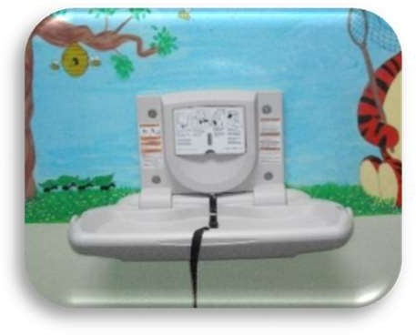
Nappy Changing Facilities:

There are two nappy changing platforms. One in the crèche area off the back hall & one in the disabled toilet.
Please take soiled nappies and wipes home for disposal as we do not have facilities for dealing with this type of waste. If you need a plastic bag please ask.

Main Kitchen
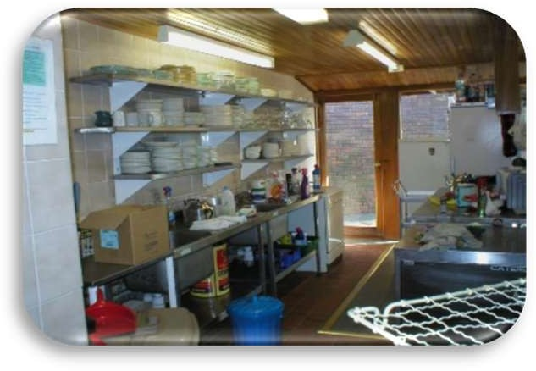
This area should only be used for the preparation of food & drink and the cleaning of cooking and eating utensils.
It SHOULD NOT be used for craft work, flower arranging, general cleaning, etc. These activities should be carried out in the utility room.

Children should be kept out of the kitchen unless under adult supervision. Kitchens can be dangerous places.

Utility Room
The Utility room (previously known as the Back Kitchen) is for general cleaning, flower arranging, craft work, etc.
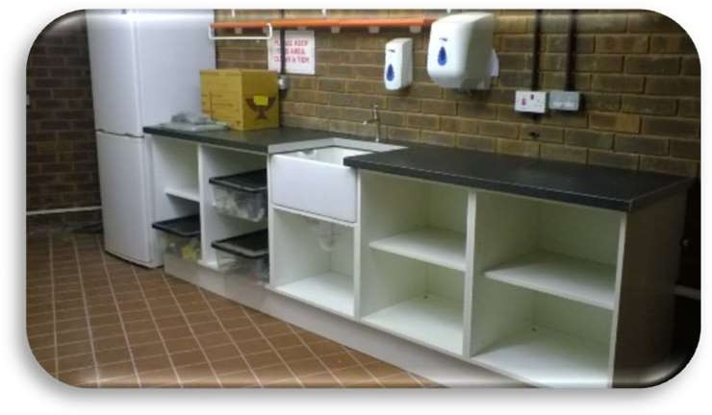
It should NOT be used for the preparation of food & drink or the cleaning of cooking & eating utensils.
Cleaning chemicals, consumables and so on are now stored in the cupboard off this area. This is fitted with a digital lock and should be kept locked when not in use.

Again, for safety reasons, children should be kept out of this area unless under adult supervision.
Rubbish

For general litter there are waste bins throughout the building, please use them.

We have a regular commercial waste collection (which we to pay for), so it is important we get disposal right to avoid financial penalties.
Recycling bins are in the main kitchen for general waste and mixed recycling. A poster above the bins clarifies the waste types
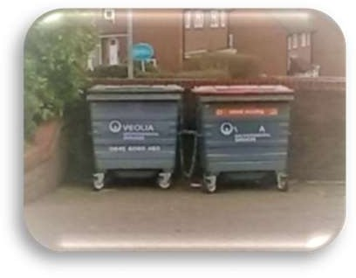
If you are in charge of, or working on an event or group, please note, ALL rubbish is to be sorted and placed in the appropriate bin.
Bagged waste should not be stored anywhere inside the building.

There are certain items that should not be put in with the general waste. These include:
batteries (there is a box for used batteries outside the office) fluorescent tubes, light bulbs, electrical equipment and large items such as tables, chairs, large plastic items, large metal items, etc.
Talk to the trustees about any such items and we will make arrangements for disposal. ANY DOUBT ABOUT THE DISPOSAL OF ANY ITEM; ASK!
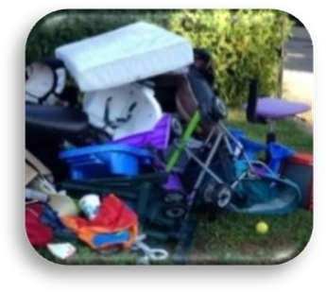

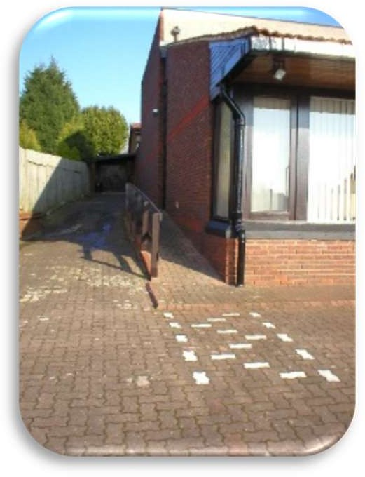
Disabled Facilities

Wheelchair access is at the side of the building. Please do not obstruct it by parking on the white painted brick area. Please note, this is not a disabled parking bay, it is an access zone. So if you park there, even with a blue badge, you could be asked to move.
An induction loop for the hard of hearing covers the whole building.

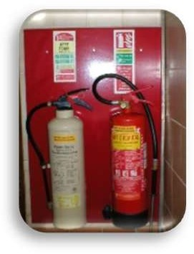
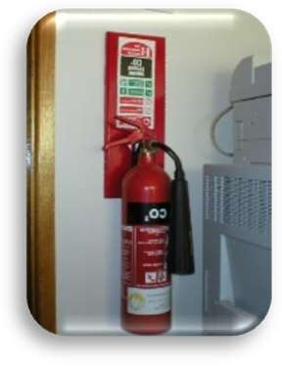
Fire Extinguishers Fire Exits & First Aid

Fire extinguishers are located throughout the
building.

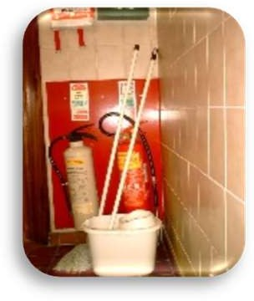
Do not obstruct access to the extinguishers.

Fire Exits
Fire exits are labelled.
EXITS ARE TO BE KEPT CLEAR AT ALL TIMES.

First Aid Box

There is a First Aid box in the kitchen and in the utility room.
The kitchen should not be used as a First Aid Room. Use the utility room, office or meeting room accessing the basin in the disabled toilet if necessary.

There are also Body Fluids disposal kits available in the utility room and disabled toilet should circumstances require.
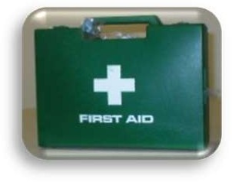
There is a telephone for emergency use in the office.

Emergency Procedures

The board have identified four possible scenarios:

- Sudden Illness/ Accident
- Power failure
- Fire
- Bomb Threat

Sudden Illness/Accident

The stewards will deal with the situation asking for assistance from the suitably qualified members of the congregation as they see fit. Everyone else should keep clear.

Power Failure

Remain in your seats until instructed by the stewards. We have facilities to see you safely out of the building.

Fire

The Pastor will lead the evacuation. Evacuate from the front. Disabled / slow moving to remain seated until the others have passed. Someone will look after you and see you safely out of the building.
Go to the assembly point in Stud Green.
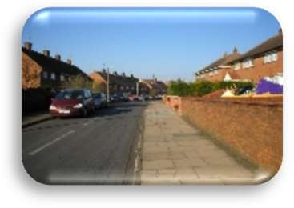
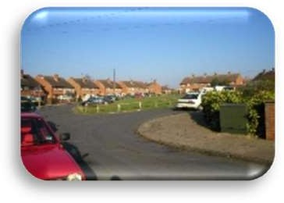

At the assembly point the Pastor to check all are present. Assist by checking that your family and those sitting around you are present.
DO NOT GO HOME DO NOT USE YOUR CAR DO NOT STOP TO PICK UP COATS ETC.

Bomb Threat

- Evacuate to the back hall.
- Remain there until given the all clear.

House keeping

If you are in charge of a group or meeting, either yourself or by delegation, carry out the following when you leave the building:

Check that everyone has left the building. This will include checking the toilets.
Put away chairs, tables and other equipment and then ensure the kitchen and utility room are left clean and tidy.
Check that all water taps are turned off and all WCs are flushed clear.
Check that all appliances are turned off.
Take out any rubbish.
Turn off the lights.
Check that all external doors are locked.
Set the alarm.
Report any problems or issues to the trustees.

LEAVE THIS PLACE AS YOU WOULD WISH TO FIND IT

The Brow, Woodside
Watford, WD25 7NW.
United Kingdom

